Problem–Solution Fit Template
Incident Lifecycle Automation in ServiceNow

1. Purpose
This template checks whether the proposed Incident Lifecycle Automation solution addresses a meaningful incident-management problem and whether the proposed approach fits the needs of intended users. Complete the template using stakeholder feedback and evidence from the project environment.

2. Problem summary
Potential problem: incident handling may become inconsistent or delayed when categorisation, prioritisation, assignment, status communication, knowledge reuse, and resolution documentation depend on manual steps.
Problem statement: How might ServiceNow support a consistent, traceable incident lifecycle from incident creation to resolution and closure while reducing repetitive manual effort?

3. Target users and their needs
End users need a clear way to report incidents and understand permitted status updates.
Service desk agents need consistent incident information, clear priorities, and appropriate assignment.
Technical support teams need useful diagnostic details and accessible knowledge articles.
Process owners need reliable records to review lifecycle handling and resolution information.

4. Proposed solution hypothesis
If selected ServiceNow capabilities—such as Incident Management, Flow Designer, Business Rules, Knowledge Management, and appropriate access controls—are configured to support the agreed process, then incident handling may become more consistent and easier to track. This is a hypothesis to validate, not a claim of measured improvement.

5. Problem–solution fit matrix
For each problem, record the user affected, proposed feature or process change, expected benefit, evidence needed, and validation result.

6. Assumptions to validate
Users can access the approved incident submission channel.
Required incident fields and lifecycle states can be configured in the available ServiceNow instance.
The project team has permission to configure and test the selected features.
Knowledge articles are available or can be represented with sample content for demonstration.
Any notifications, assignment automation, or change links are included only if they are configured and tested.

7. Validation plan
Interview or consult representative users and support agents.
Walk through sample incident scenarios in a development or training instance.
Check whether users can submit, track, and understand an incident using the proposed process.
Record issues, feedback, and changes required before finalising the design.

8. Decision record
Problem validated? Yes / No / Partially:
Solution fit: Strong / Moderate / Needs revision:
Evidence reviewed:
Changes required:

Problem–solution fit matrix
Problem / need | Affected user | Proposed solution | Expected benefit | Evidence / status
Slow manual triage | Callers and service desk agents | Auto-categorize and calculate priority using impact and urgency | Faster, more consistent triage | Proposed; validate with stakeholders
Incidents reach the wrong team | Service desk and resolver groups | Route by category and subcategory with Flow Designer | Reduced reassignment and delay | Proposed; verify in test instance
SLA deadlines are missed | Incident manager and assignees | Send threshold warnings and breach escalations | Earlier intervention and visibility | Proposed; measure during testing
Incomplete resolution records | Agents and callers | Require resolution code and notes before resolving | Better auditability and reporting | Proposed; test Business Rules
Repeated incidents take time to diagnose | Agents and knowledge managers | Suggest related Knowledge articles | Faster diagnosis and reuse of fixes | Proposed; validate article relevance
Change-related incidents lack coordination | Agents and change managers | Link Change Requests and manage On Hold state | Clearer dependency tracking | Proposed; validate workflow

Process Diagram
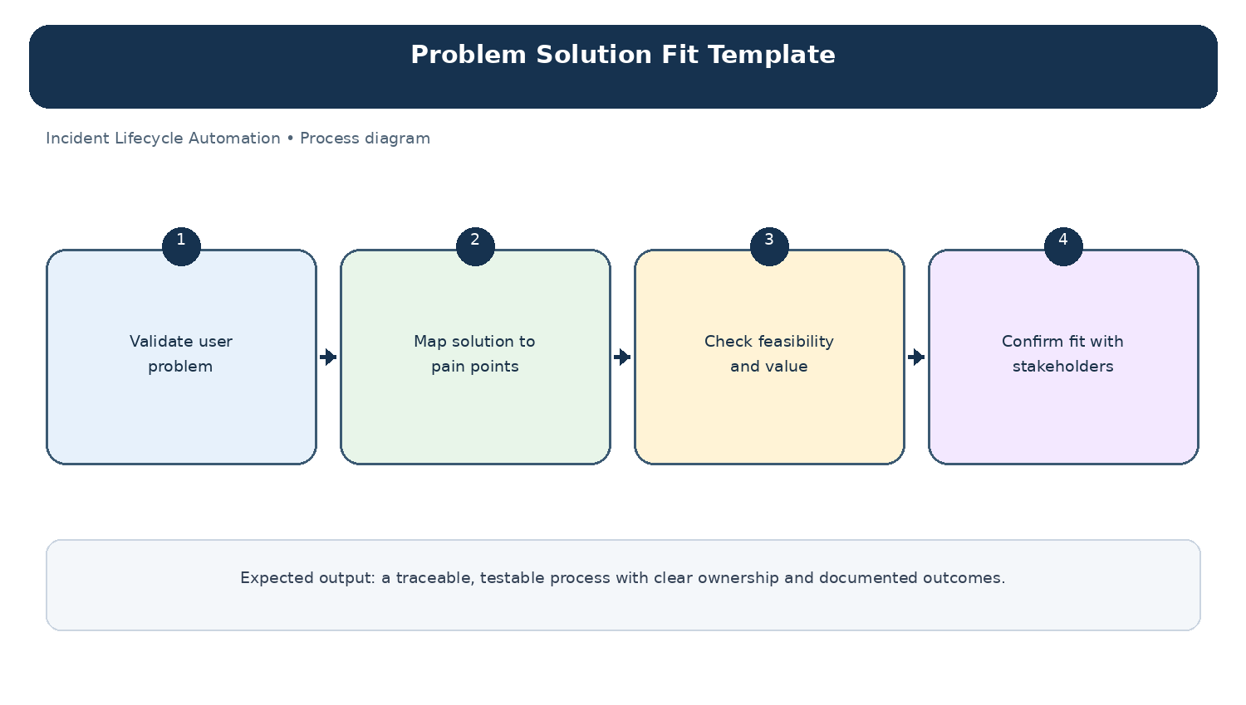
Diagram: Problem Solution Fit Template — project-specific process overview.

